**InnovateX - Tech Conference Website**

InnovateX is a responsive and interactive website designed for an annual tech conference. It features multiple pages, including Home, About, Schedule, Speakers, and Contact, ensuring seamless navigation and accessibility. The site incorporates **modern UI/UX design**, **dynamic content loading**, and **interactive elements** like dropdown menus and modals. Advanced JavaScript and TypeScript functionalities enhance the user experience, including a **live countdown timer** and a **filterable conference schedule**. Built with **CSS Grid and Flexbox**, the site ensures a sleek, adaptive layout with smooth animations for an engaging experience on all devices.

**1.Home Page**

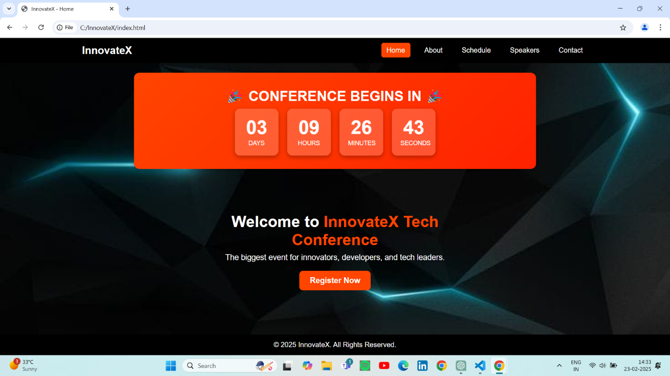

**2.Registration Page**

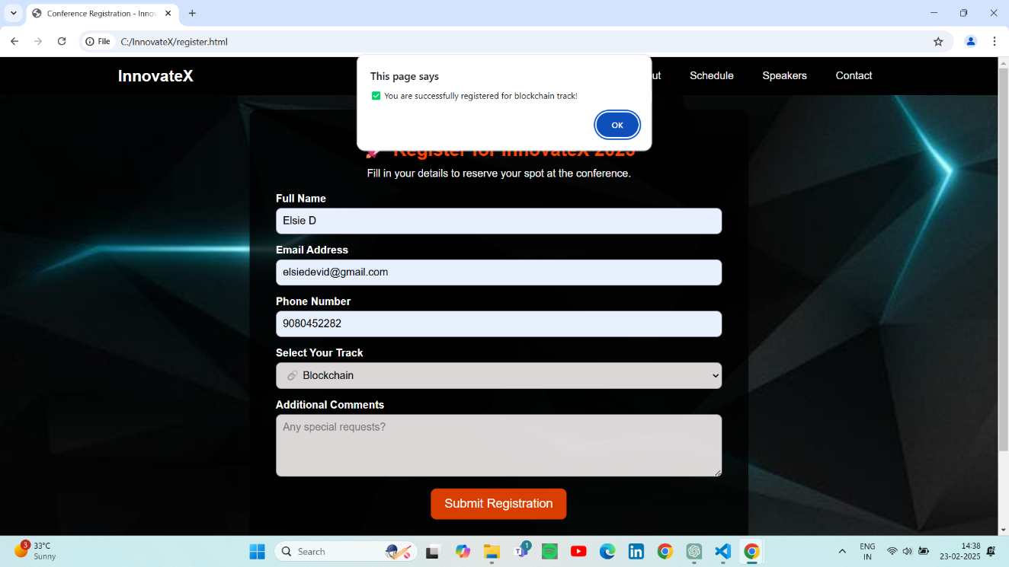

**3.Selected Track Speaker Page**

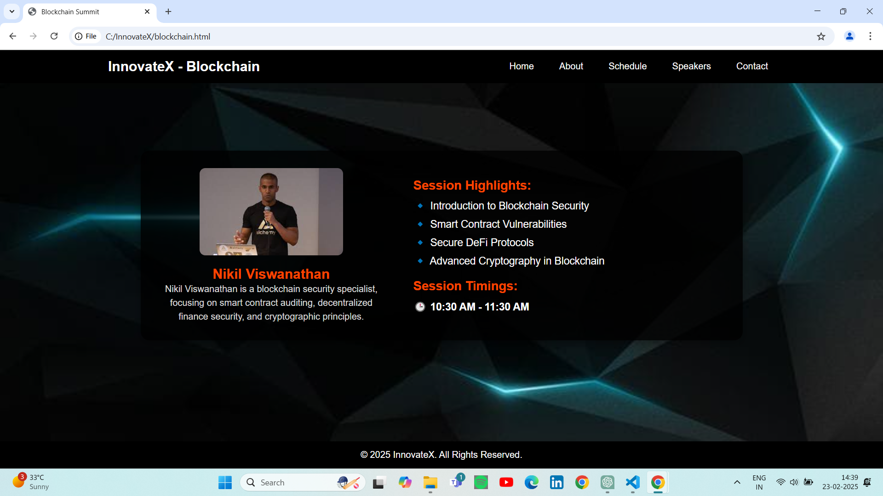

**4.About Page**

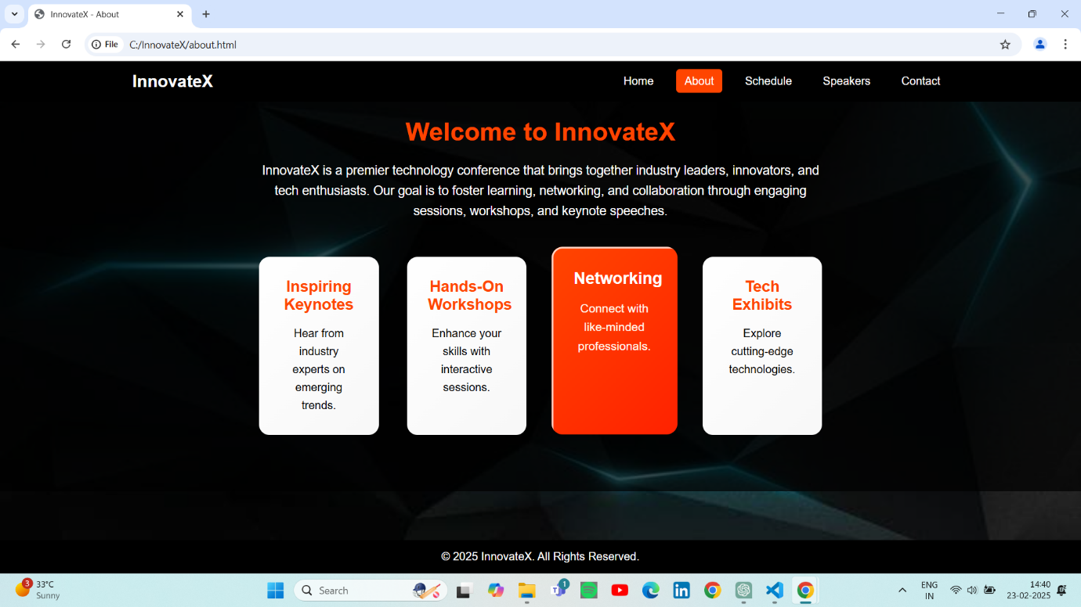

**5.Schedule Page**

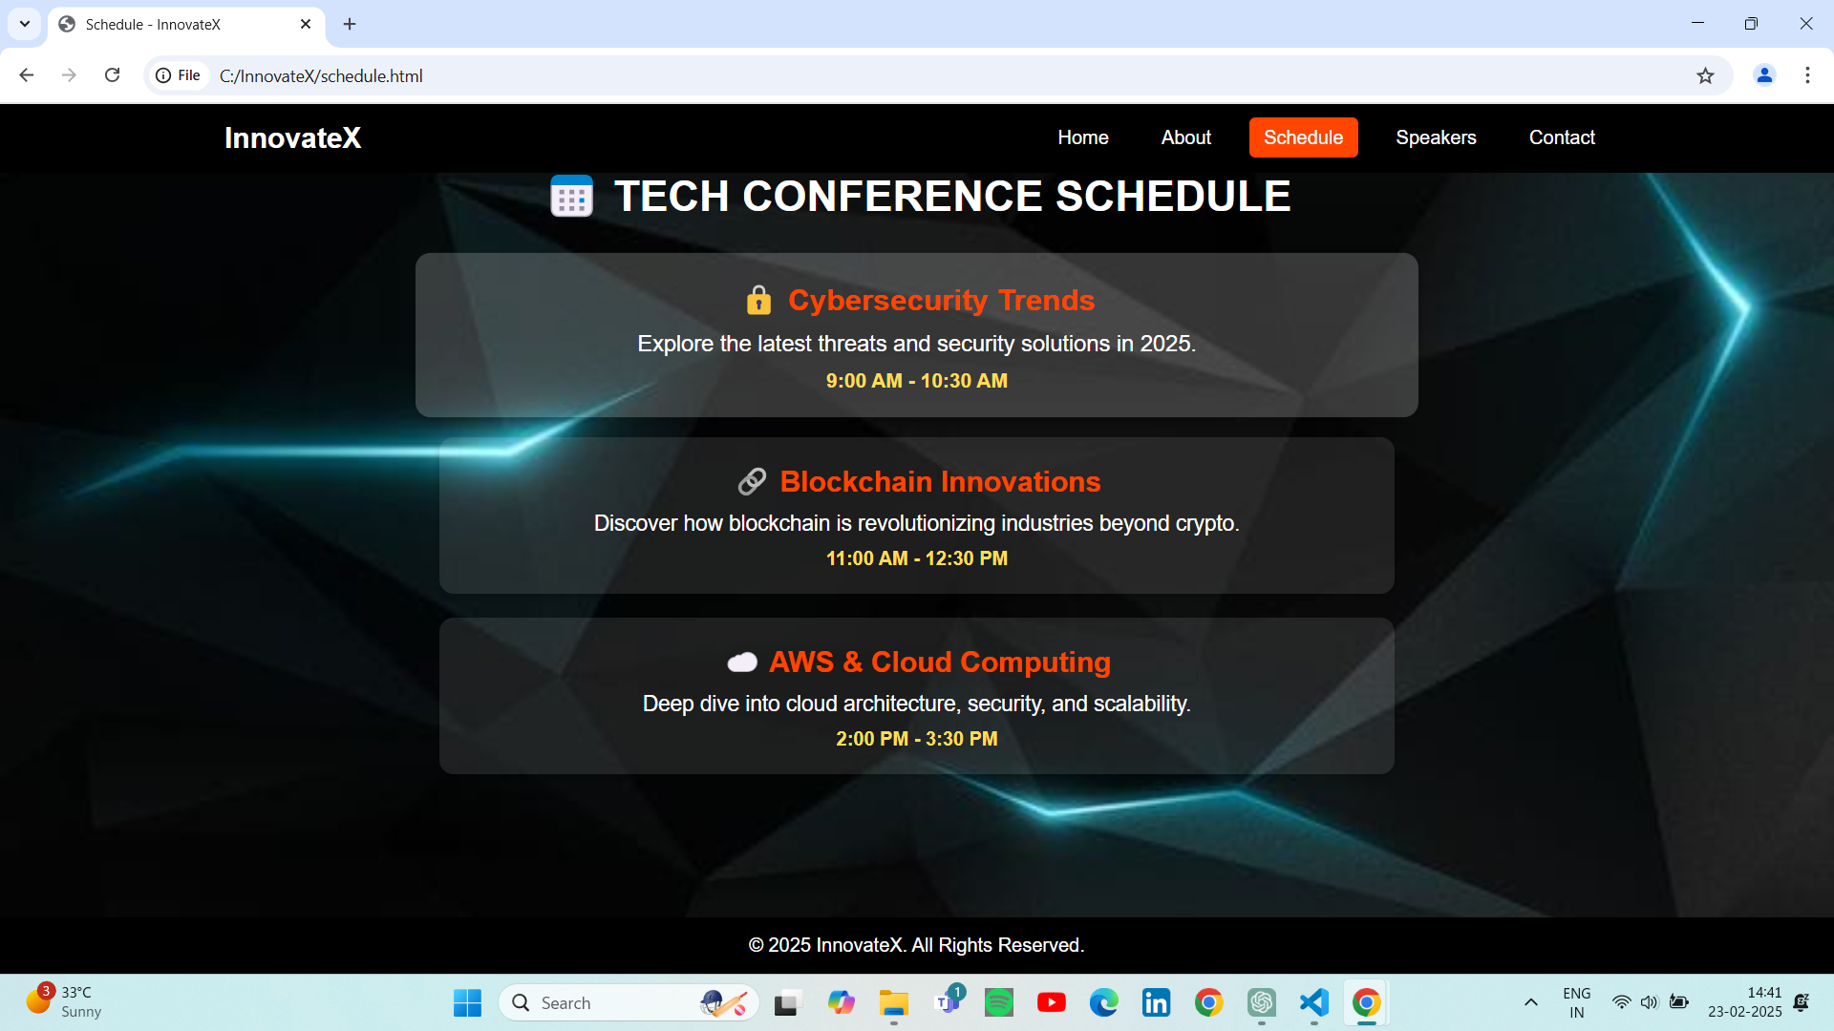

**6.Speakers Page**

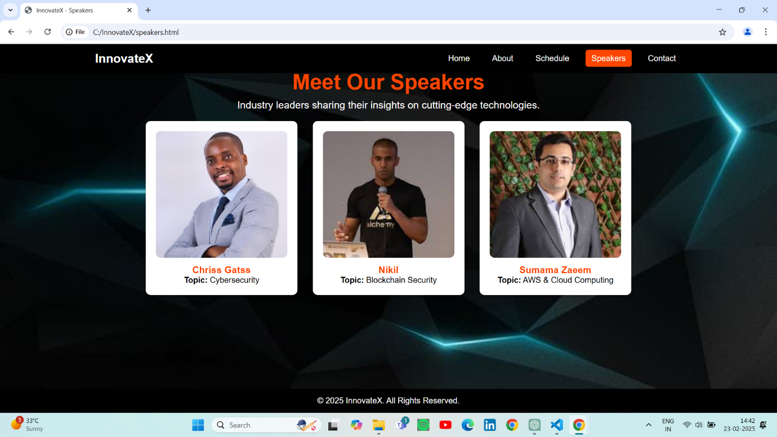

**7.Contact page**

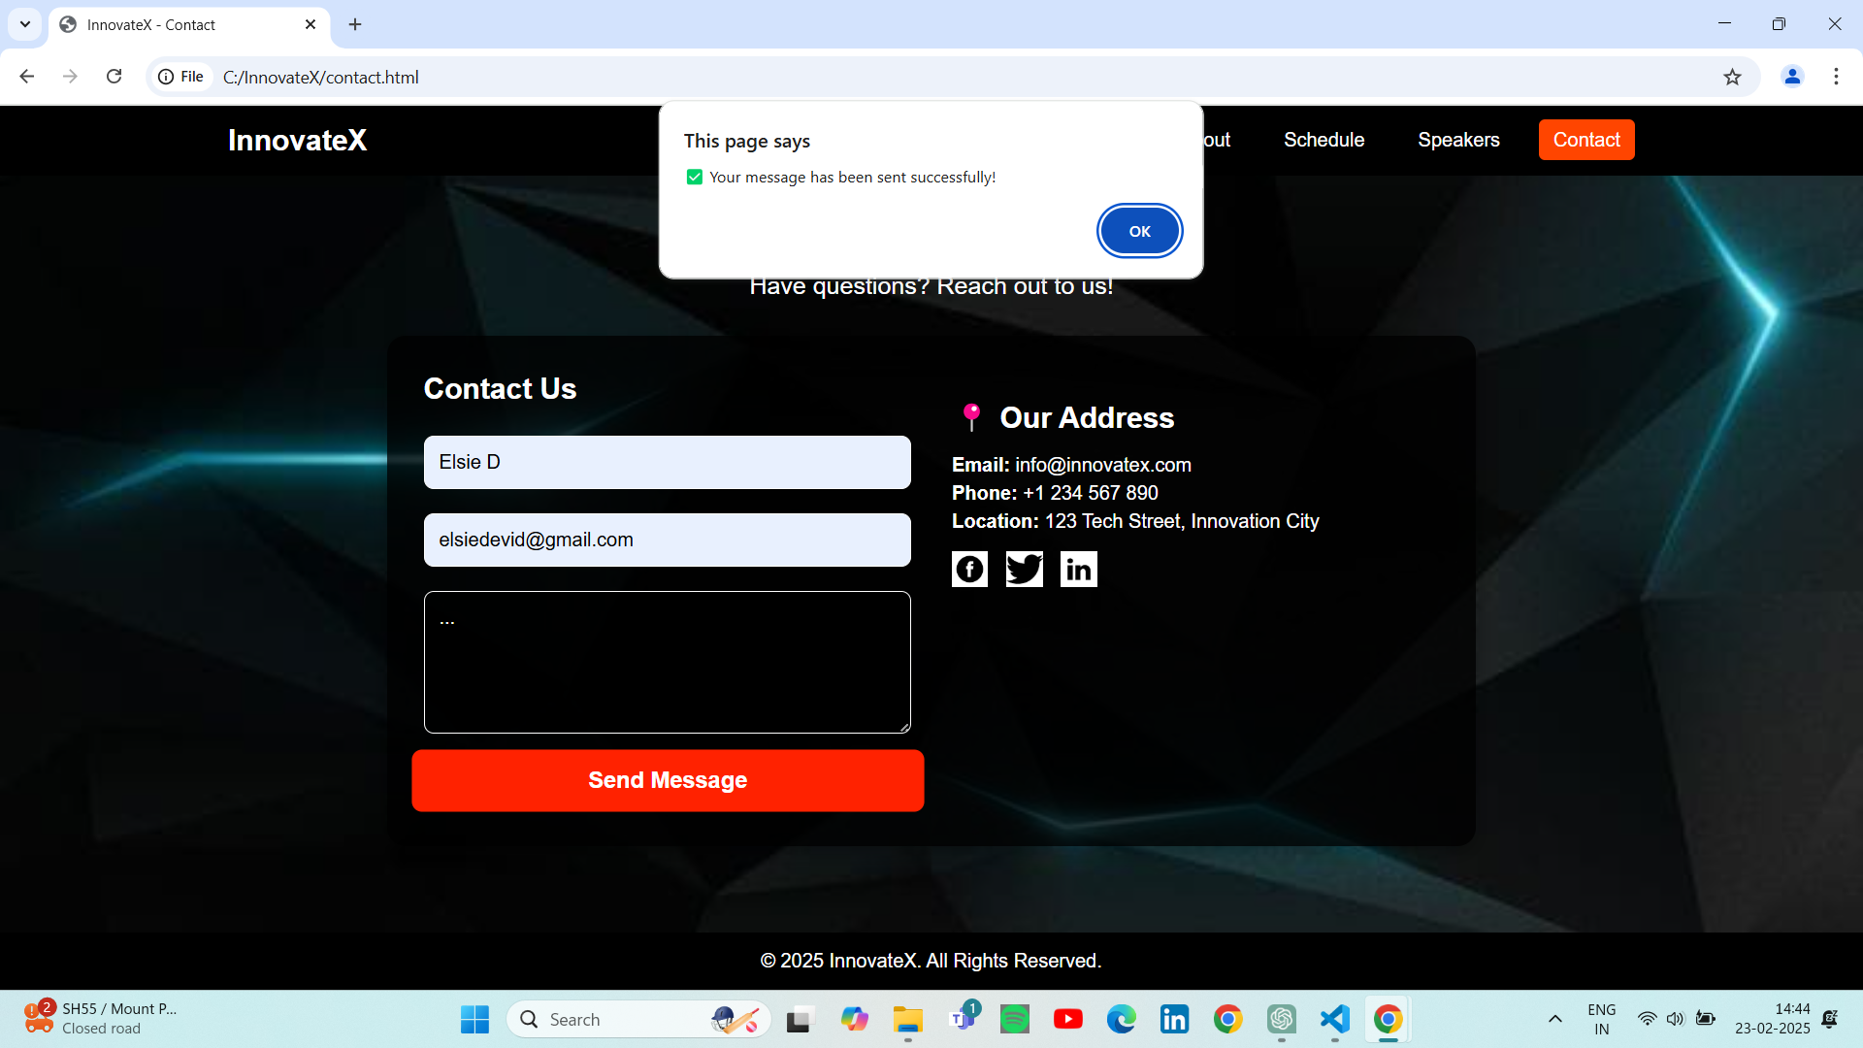

**8.Cybersecurity Speaker page**

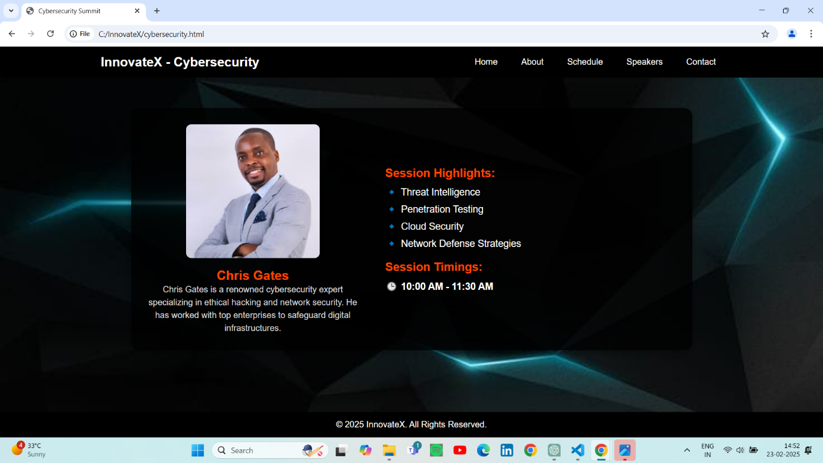

**9.AWS & Cloud Computing Speaker**

